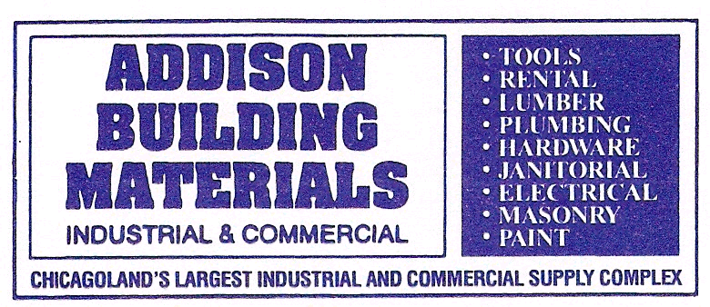


3201 S. BUSSE ROAD
ARLINGTON HEIGHTS, IL 60005
847-437-1205 FAX 847-437-4183
www.AddisonBuilding.com
Sales@AddisonBuilding.com

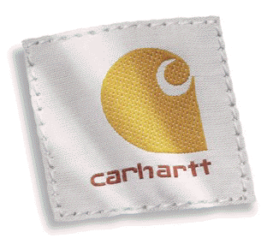
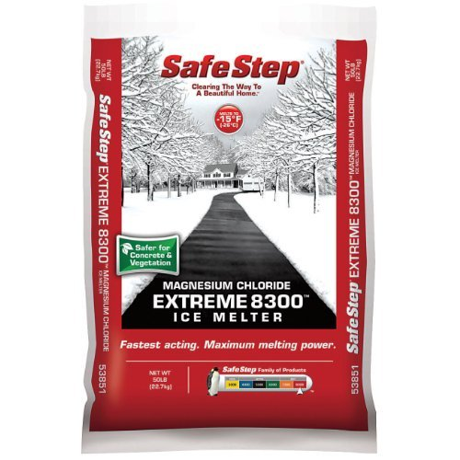
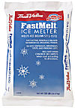
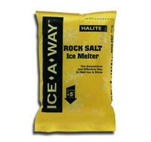
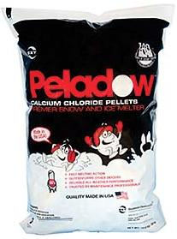

BUY ONE CARHARTT ITEM & GET
A SECOND ITEM OF EQUAL OR LESSER VALUE
50% OFF

Sale Includes ALL Carhartt Items: Coats, Jackets, Sweatshirts, Bibs, Coveralls, Gloves, Socks, Hats and More…
PRE-SEASON PROMOTION ON ALL ICE MELT PRODUCTS
GET READY FOR THE COLD WITH CARHARTT GEAR
Rock Salt
Melts ice and snow down to 5° F 50RS 50LBS $8.99 $7.69

Sodium/Magnesium Chloride Mix (FastMelt)
Melts ice and snow down to -7° F 183339 12LBS (Jug) $11.95 $9.99
Safe on sidewalks and grass 20PC 20LBS $11.29 $8.95
50PC 50LBS $13.99 $11.69

Calcium Chloride
Melts ice and snow down to -25° F 50CCP 50LBS- Pellets $21.99 $17.80
Safe on sidewalks and grass

Magnesium Chloride
Melts ice and snow down to -15° F
Does not leave white residue on carpets/pet safe 50MC 50LBS $36.89 $32.49

If we do not stock an item that you are looking for, we can get you a price and availability
for that item. Addison will do our best to find and order what you need.
DE-ICING PRODUCT SKU SIZE RETAIL SALE

